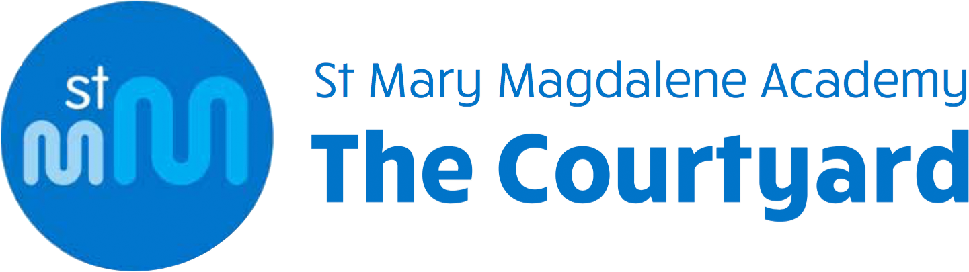
PAIL Facilitator: World Studies/Humanities
Person Specification
SPECIFICATION | ESSENTIAL | DESIRABLE
Education/Training | - Have a relevant HLTA/NVQ Level 2 qualification or above  - Or have a degree | - Evidence of further personal and professional development e.g. online courses in autism/SEN/SEMH
Knowledge | - Confident knowledge in aspects of world history, geography and world religions | - Have experience of seeing/being involved in any kind of Humanities lessons in either primary or secondary school (as an adult)
Experience, Skills and Attributes | - Experience of teaching or tutoring young people  - The ability to use an imaginative range of teaching strategies to promote high expectations and high levels of support and challenge in the classroom  - The ability to plan for progression in learning  - The ability to assess and record pupil progress against set objectives  - The ability to establish a safe and purposeful working atmosphere that supports learning and in which pupils feel secure and confident  - An enjoyment of working with young people  - A commitment to raising achievement  - A level of proficiency in ICT in order to use technology to support learning in the classroom | - Experience of teaching or tutoring young people with special educational needs
Personal Qualities | - Flexibility – to be able to think on your feet and adapt a lesson according to current affairs, pupil interest, the weather!  - A sense of humour  - Energy, drive and enthusiasm  - Commitment to own personal and professional development  - The ability to be a reflective and evaluative practitioner who is willing to learn and develop  - A willingness to contribute to extra-curricular activities | - An interest/ability in sport/music/drama/the environment/cooking/crafting to be shared as an extra-curricular activity

