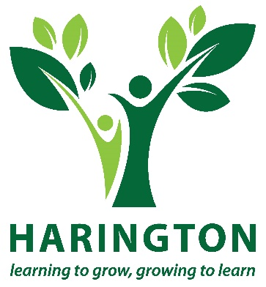
Skills Pathways at Harington
Skills to Shape Your Future!

What learners say about Harington
“I like it here they are helpful and encouraging. When I came here I had no qualifications now I have a handful, thank you! Kieran

“I like to come here because I like to work, like to plant, made friends makes me happy.” Umair

“I have learned how keep safe with tools. I have made a lot of friends since I have been here and the teachers have been nice to me. I have learned how to plant.” Sanchez

“I am enjoying the Harington it is nice. I enjoyed the residential in the Isle of White.” Robin

“I have achieved a lot – I have passed my gardening qualifications and literacy and numeracy. The staff are helpful towards you and are keen for you to do well. You might feel that the Harington is not the right place for you but trust me once you come here you will gain a lot of self esteem and confidence once you’re ready to move on.” Khiry

“I realise now it is about being positive and believing in yourself. It is a supportive environment with no pressure. They help you in the areas you need to work on and give you support – it’s about what you want. I completed several work experiences to build up my skills. Now I feel I am ready for employment.” Gemma

“It’s good, nice scenery and it’s beautiful. I am gardening and I like it a lot.” Joseph

“People have treated me fairly. I have made a lot of new friends since I have been here, people are kind to me. The teachers are nice to me. I have learnt how to plant and weed.” Anna

What is Harington?
Harington is a training centre. It is a charity and we specialise in working with people of different abilities to help them become more independent and ready to work or go to college.
It is a small centre and this allows us to run the training in small groups and to really get to know our learners well. We always try hard to make sure that everyone gets the right help so that they can make progress, get qualifications and move on to work or a college course that will really suit them and will help in the future.

What are the Skills Pathways?
Every learner is different, has different experiences and goals and therefore our Skills Pathways are flexible and designed to meet a wide range of needs from Entry level to Level One.
Each learner will have an individual programme designed to help them to achieve qualifications and to progress toward greater independence, employment or further education.
English, Maths
and ICT
Work Skills

Personal and Social Developmentttt
There are three core elements to the programme: work skills, personal and social development and functional skills (English, Maths and ICT ). When you start we will help you to work out the skills you need to improve in each of these areas and put together a plan that suits you. You will have the opportunity to work toward these qualifications:

OCN Progression – Entry 3 – Level 1

C&G Skills for working life Entry Level
OCN Personal Progress Entry 1
OCN Progression Entry 3 – Level 1 Functional ICT (Entry 1 – Level Two)
OCN Independent Living Skills - Entry Level Functional Maths (Entry 1 – Level Two) OCN Using Employability Skills Entry Level Functional English (Entry 1 – Level Two)

All pathways also include the opportunity to get work experience. The extra qualifications for each pathway are shown on the next page. We also have social events, trips and activities that will help you get to know other learners and make friends. In September each year we also have an activity week in the Isle of Wight that is free for learners

There are 3 Skills Pathways available: Horticulture, Retail and Choices

.

Skills Pathway: Horticulture
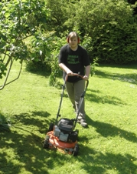
This is a great course if you like working outdoors. If you want to be a gardener it’s a good starting point, but lots of the skills you will learn can be used in any job. We have a large site where you learn about gardening and our own gardening company that employs some of the leavers each year.
Qualifications on offer:
- City and Guilds Skills for Working Life (Land-based) – Entry 2 & 3
- City and Guilds Practical Horticulture Level 1
- City & Guilds Practical Horticulture Level 2

Skills Pathway: Retail
The Retail Pathway would be right for you if you are ready to try out working in a shop. The course will help you learn and practise the skills that retail employers are looking for such as: communication, helping customers, working safely and following instructions. If you aren’t ready for work experience the elements of the Choices pathway will help you to gain skills and confidence while you learn the basics of retail. You can even start in the Harington’s own charity shop. Qualifications at Entry Level 3, Level 1 and Level 2

Skills Pathway: Employability
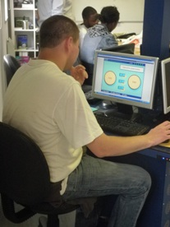
Employability will help you to explore the world of work and to be more independent. If you’re not sure about the type of job you would like then you can try out different types of work experience and learn the basic skills that all employers look for. If you want to move on to the next step in your studies but need to build up your confidence and qualifications or you want to get ready for a more independent life then the Employability Pathway can help you.

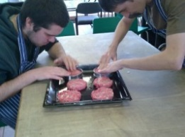 | 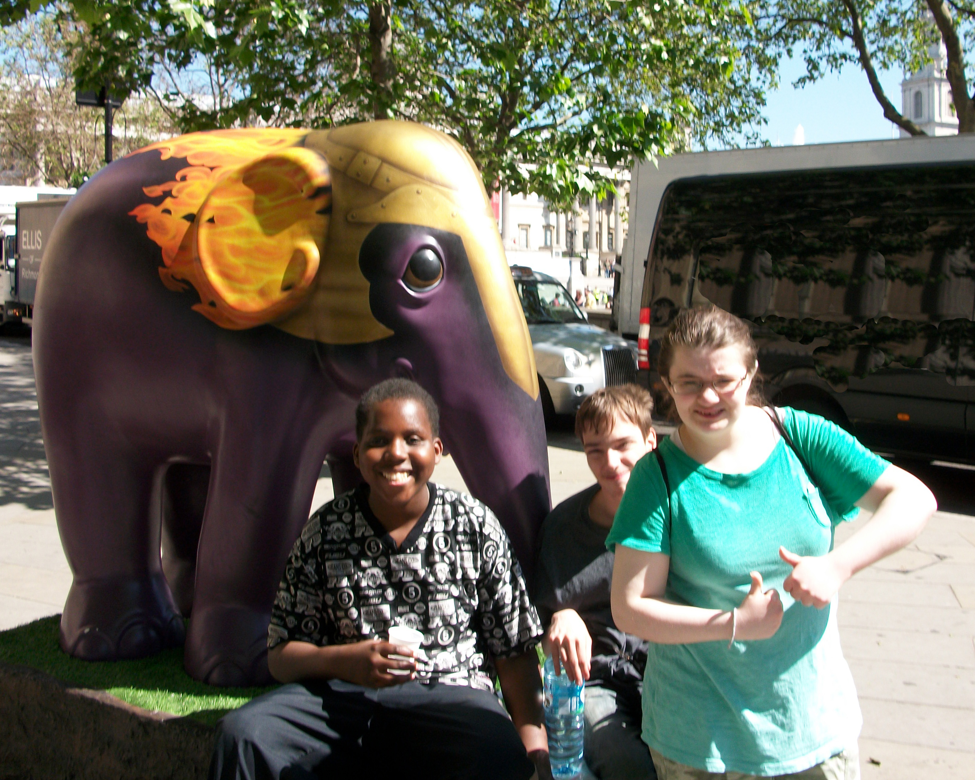

Frequently asked Questions:
Who can apply for Skills Pathway at Harington?
You need to be aged 16 – 18, or up to 24 years if you have an Education Health and Care Plan
How do I apply?
Call Mandy or Michelle on 020 3457 7989 or email info@harington.org.uk. We will agree a time for you to come and look around and you will be able to apply for a course. If your application is successful you will be invited to do a taster at Harington to help you decide if it is the right place for you.
How much does it cost?
The training is free, and if you are aged 16 to 18 years you may be able to apply to our bursary fund. If you are over 19 and have an Education Health Care Plan you may still be able to apply for a Harington Bursary.
What happens at the end of my course?
When you are ready to move on, you will get support from the Progression Team in finding a job or further training. The Team will also provide aftercare when you have left Harington for at least 3 months.
Will I get help with work experience?
The Progression Team will organise your work experience placements. We will travel train you and a job coach will go along with you to help you to settle in. You will have regular reviews at your placement.
What learning support can I get at Harington?
At the beginning of the course we will get to know you and find out what support you need.
We can provide:
- Small group size | - A key worker |  | - Counselling
- Job coaching | - Travel training |  | - Regular reviews
- Literacy and numeracy support |  | - Advice and guidance
- Personalised support (subject to funding availability)
We can apply for funding for personalised support, such as a support worker or signer. If you are likely to need this please let us know when you apply. Transport/fares to enable work experience can be funded by us, but transport from home to Harington should be arranged by parents/carers or through your Local Authority.
If you have any further questions please call us on 0203 457 7989

How to find us
Address: The Harington Scheme
55a Cholmeley Park
Highgate
London
N6 5EH

Buses: 4, 10, 17, W5, 41, 43,134, 143, 210, 214, 271, 263 , 390, 603, C11

Nearest Tube: Archway

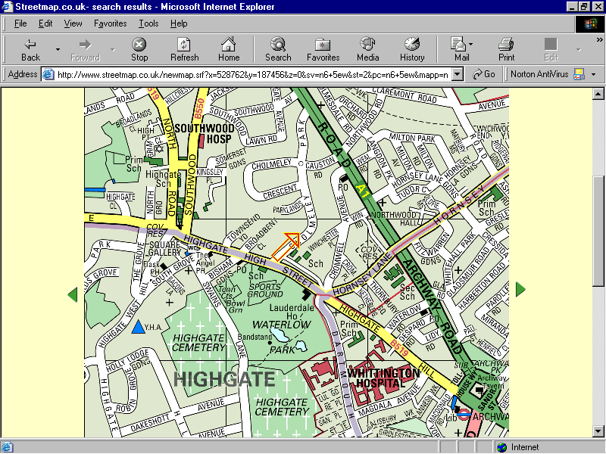

Directions from Archway
Get a bus (143,210,271) to Highgate Village (3rd stop from Archway) or walk up Highgate Hill to the third set of traffic lights. Cross Highgate High Street at the traffic lights and walk down hill past the lamp post and take the first left into Cholmeley Park. Look for a turning on the left that says Private Road (next to Furnival House) and follow this driveway round to the left.
Directions from Highgate Station (Archway Road)
Cross over and then walk down Archway Road (down hill), past the main junction by Jackson’s Lane and Cholmeley Park is the next right. Walk up Cholmeley Park, past the mini roundabout, up the hill and take the second right down the private road at the side of Furnival House (opposite 55a).
Contact: Michelle or Mandy on 020 3457 7989
Email: info@harington.org.uk Website: www.harington.org.uk

