Overview of Project SEARCH at Moorfields Eye Hospital
NHS Foundation Trust
What is it?
Project SEARCH is a supported internship programme for young people with learning disabilities and/or those on the autistic spectrum. It is a unique business led, one year education to work programme that takes place entirely in the workplace. There are three on-site programme delivery partners: the host employer Moorefields Eye Hospital NHS Foundation Trust, the education establishment City & Islington College and supported employment services Kaleidoscope Sabre and the prgramme offers total workplace immersion, facilitates a seamless combination of employability skills intruction, career exploration and hands-on training through a series of job rotations within the host business.

How does it work?
The programme runs five days a week, for a full academic year. Typically, interns complete three work placements between 10 – 12 weeks in length. Those taking part will have learning disabilities and/or autistic spectrum conditions. Interns are expected to travel independently to the workplace where possible and required to follow the Moorfields Eye Hospital NHS Foundation Trust induction, new employee checks, Occupational Health guidelines as well as work to the Trusts visions, values and behaviours. (Follow the link to a short video of the programme at Whipps Cross Hospital: https://youtu.be/0HU3jM0ppJE as an example of what a typical programme is like)

Benefits to Moorfields Eye Hospital NHS Foundation Trust
- Access to a talent pool of enthusiastic, motivated and well trained prospective employees.
- Potential cost and efficiency savings in recruitment and overtime or agency staff payments.
- Enhanced business reputation as a disability confident organisation that actively supports equality & diversity in the workforce by giving a person with a disability a rewarding job and increased independence.

Case Study
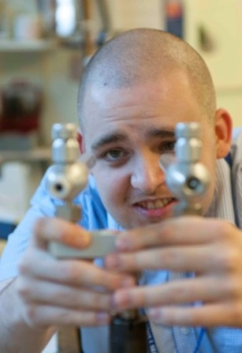
Sam was a Project SEARCH intern five years ago on another site and he always wanted to be a Porter. His first work placement in Medical Engineering enabled him to develop a clear understanding of the different areas and wards in and around the hospital. This led to a placement in Portering for his second and third rotations. Sam is now employed as a full time Porter.
“Project SEARCH helped me with my independence and self-esteem” Sam said when asked what Project SEARCH has done for him, “It really is the best thing for people like me with special needs, to help them get a job”.
“This has been life changing for us” said Sam’s father. “We can’t thank you enough for what you have done for Sam”. This is just one of the now over 500 success stories achieved in partnership through Project SEARCH programmes all over the UK.

Typical Departments that are often involved:
Departments offering placements often include: Pathology, X-Ray & Medical Imaging, Coffee Shop, Medical Records, Estates & Facilities, T.S.D.U (Sterile Services), Restaurant, Medical Engineering, Domestics, Portering, Outpatients Receptions, Main Stores, Domestic Stores, Clinics, Learning & Development, Admissions and Wards.

What has it achieved?
To put it into perspective, the national percentage of people with learning disabilities in paid employement in the UK is around 6.7%. Project SEARCH progarammes across the UK now have over 500 graduates in full time paid employment, many working for NHS organisations or in the wider community. This represents a national average of 65% over the last five years and the international average for employment outcomes stands at 73%.

For further information please contact Emma Lord on:
T: 07458003795 | E: Emma.lord@candi.ac.uk

